US Nanny Association US Nanny Association Applicant Agreement Page 1 of 6

Phone: (941) 773-9020 9040 Town Center Parkway, Lakewood Ranch, FL 34202

**Application Agreement**

This agreement, together with the US Nanny Association Credential Step by Step Guide, constitutes a binding contract between the applicant and the US Nanny Association upon acceptance by the US Nanny Association. Read this enrollment agreement thoroughly and then sign. Upload the signed form online in your private portal.

**Part I – Applicant Information**

Legal Name: Click or tap here to enter text.

First Middle Last (Family) Suffix

Preferred Name: Click or tap here to enter text.

Birthdate: Click or tap here to enter text. Age: Click or tap here to enter text.

(mm/dd/yyyy)

Mailing Address: Click or tap here to enter text. Click or tap here to enter text.

Street Address City, State, and Zip Code

Email:Click or tap here to enter text. Phone: Click or tap here to enter text.

Citizenship:  US Citizen or Permanent Resident  Other or International

Ethnicity:  Hispanic or Latino  American Indian or Alaska Native  Asian  
  White  Black or African American  Two or more

Native Hawaiian or Pacific Islander  Other

How did you hear about the US Nanny Association Credential? **Check all that apply**.

Web Search  Advertisement  Person (Family/Friend)

Facebook/Instagram  YouTube  Person (Employer)

Scholarship  Agency:Click or tap here to enter text.

Other: Click or tap here to enter text.

US Nanny Association Applicant Agreement Page 2 of 6

**Part II – Select Review Course or Credential**

Check all that apply. All review courses and credential requirements are due 90 days from enrollment. Time starts on day of enrollment and all work can be completed at applicant’s own pace within the 90.

Review Course: Nanny and Specialist Childcare 6.5 clock hours

Review Course: Newborn and Infant Care Professional 10.5 clock hours

Review Course: Professional Nanny and Childcare 17 clock hours

Nanny and Professional Childcare (NCP, NS) Credential

Newborn and Infant Care Professional (NICP, NIS) Credential

Professional Nanny and Professional Childcare (PNCP) Credential  
 Certification Renewal (Every 3 years)

**Part III – Fees and Tuition**

Check all that apply.

Review Class (NCP, NS) $149

Review Class (NICP, NIS) $249

Review Class (PNCP) $349

NCP and NS Credential $299

NICP and NIS Credential $299

PNCP Credential $299

Certification Renewal $199

**Part IV – Methods of Payment**

Full payment at time of signing enrollment agreement by credit card or PayPal

**Part V - Cancellation and Refund Policy**

All review class and credential fees are non-refundable.

**Part VI – Important Information**

I agree to the following:

1. I understand all program requirements and policies are available online in the Step by Step guide. I acknowledge that I have received a copy and I have reviewed it in its entirety before enrolling. I understand it is my responsibility to familiarize myself with these policies.
2. I understand I am not permitted to share my account or log in information with anyone for any reason and all materials used in the courses and certificate programs, including video lessons, quizzes, and tests, are copyrighted, and cannot be shared.

US Nanny Association Applicant Agreement Page 3 of 6

1. I understand I have 90 days to complete all courses and program requirements from the purchase date.
2. I understand and agree that the US Nanny Association does not conduct employment assessments, make hiring recommendations, or act as an employment agency. I will not represent or imply otherwise to any third party, including potential employers. I acknowledge that the US Nanny Association’s certification process is limited to reviewing submitted documentation related to training, education, and work experience. The US Nanny Association does not independently verify, guarantee, or validate the quality, accuracy, or completeness of any training, work experience, or background checks conducted by third parties or organizations unaffiliated with the US Nanny Association.
3. I understand that with successful completion of a credential program, I am authorized to communicate on resumes and professional sites such as LinkedIn and job posting board, the following: US Nanny Association Nanny and Childcare Provider (NCP), US Nanny Association Nanny Specialist (NS), US Nanny Association Newborn and Infant Care Professional (NICP), US Nanny Association Newborn and Infant Specialist (NIS) or US Nanny Association Professional Nanny and Childcare Provider (PNCP).
4. I understand that if the objective of enrolling in this program is to gain employment, it is incumbent upon me to seek my own employment through my own endeavors. The US Nanny Association does not provide placement services and does not guarantee employment. I understand the US Nanny Association is not responsible for employment decisions between myself and another entity.
5. I understand that any controversy or claim arising out of or relating to the agreement or the breach thereof, shall be settled by arbitration. The number of arbitrators shall be one. The place of arbitration shall be Manatee County, Florida and Florida law shall apply.
6. I have read and agree to the US Nanny Association’s Code of Ethics and Professional Conduct.

**Part VII – Important Information**

Grounds for Termination  
I agree to comply with the US Nanny Association Code of Ethics and Professional Conduct, rules and policies and understand that the US Nanny Association shall have the right to terminate this contract and my enrollment at any time for violation of rules and policies. I understand that the US Nanny Association reserves the right to modify the rules and regulation, and that I will be advised of any and all modifications.

Completion Requirements

I understand that to complete the review courses and/or credentials and to receive the certification, I must successfully complete all the requirements as specified in the Step by Step guide, pass all proficiency exams with at least an 80%, submit all required documentation including but not limited to high school diploma, employer references, CPR and First Aid, childcare training, childcare work experience, passing a background checky and satisfy all financial obligations to the US Nanny Association.

By enrolling and participating in any educational course offered by US Nanny Association, I agree that it will provide me with the material and information necessary to satisfy the course requirements for either the US Nanny Association credential programs or continuing education programs that you purchase and attend. THIS IS NOT A GUARANTEE THAT I WILL PASS ANY LICENSING OR CERTIFICATION REQUIREMENTS OF ANY STATE, GOVERNMENTAL, OR OVERSIGHT ORGANIZATION OR ASSOCIATION.

US Nanny Association Applicant Agreement Page 4 of 6

I must ensure that I meet all other requirements to qualify to become licensed and/or certified. My failure to pass a licensing or certification examination or to fulfill any other licensing or certification requirement is beyond the control, fault or cause of the US Nanny Association or Amslee, LLC. I agree to fully release and waive any and all claims against the US Nanny Association or Amslee, LLC and all agents, representatives, and volunteers relating to your failure to become licensed or certified or to pass any of the requirements to become licensed or certified by any state, governmental, or oversight organization, or association. This waiver is intentional, knowing and voluntary and done on my behalf without any undue duress or influence the US Nanny Association, Amslee LLC or any agent, representative, volunteer or Counsel of the US Nanny Association.

Non-Transferable

Enrollment in any program, course, or certification offered by the US Nanny Association is personal to the applicant and may not be transferred, assigned, or shared with any other person or entity.

Placement Services

I understand that the US Nanny Association has not made and will not make any guarantees of employment or salary upon my graduation. The US Nanny Association does not provide job placement assistance.

Intellectual Property

All course content, program materials, documentation, branding, logos, trademarks, and intellectual property are owned by the US Nanny Association and/or Amslee, LLC. Use of any material for purposes outside the scope of personal credentialing is strictly prohibited without prior written consent. Reproduction, distribution, or dissemination in any form is a violation of intellectual property laws and may result in civil or criminal penalties.

Right to Revoke Certification

The US Nanny Association reserves the right to revoke or suspend certification or credentials at any time if the certified individual is found to have violated the Code of Ethics and Professional Conduct, misrepresented qualifications or documentation, or engaged in conduct deemed harmful to the integrity of the profession or the US Nanny Association.

No Warranties

The US Nanny Association and Amslee, LLC make no warranties or representations, express or implied, regarding the accuracy, completeness, or applicability of any information or materials provided during the credentialing or educational process. All services and materials are provided “as is” without warranties of any kind, including but not limited to warranties of merchantability or fitness for a particular purpose.

Waiver of Liability

I hereby release, discharge, and agree to hold harmless the US Nanny Association and Amslee, LLC, its trustees, agents, employees, representatives and volunteers, from any and all liability arising out of or in connection with my participation in the Nanny and Childcare Provider programs. For purposes of this Release, liability means all claims, demands, losses, causes of action, suits or judgments or any kind that I or my heirs, executors, administrators, and assigns may have against the US Nanny Association or Amslee LLC, its trustees agents, employees, representatives and volunteers, because of a failure to pass any course or class or obtain any particular grades or credentials, personal injury, accident, illness, or death or because of any loss or damage to property that occurs to a person including me or to my

US Nanny Association Applicant Agreement Page 5 of 6

property during the Nanny and Childcare Provider programs and that results from any cause including but not limited to the passive or active negligence or other acts of the US Nanny Association or Amslee LLC, its trustees, agents, employees, representatives and volunteers, other than fraud, willful misconduct, or a knowing violation of the law.

Dispute Resolution and Arbitration

Any dispute, claim, or controversy arising out of or relating to this agreement, the credentialing process, or any related service shall be resolved solely through binding arbitration conducted in Manatee County, Florida under the rules of the American Arbitration Association. By agreeing to arbitration, the parties waive any right to a jury trial or to participate in a class action lawsuit. The prevailing party shall be entitled to recover reasonable attorney's fees and costs.

Indemnification

Notwithstanding any insurance coverage that may be in effect, and in addition to any other undertakings referred to herein, I agree, to the fullest extent permitted by law, to defend, indemnify, and hold harmless the US Nanny Association and Amslee, LLC, including their trustees, officers, directors, employees, agents, representatives, and volunteers (collectively, the “Releasee”), from and against any and all liabilities, claims, demands, losses, damages, causes of action, judgments, costs, expenses (including reasonable attorneys’ fees), or obligations of any kind arising directly or indirectly from:

* My participation in any program or activity associated with the US Nanny Association or Amslee, LLC,
* My use or misuse of any materials or intellectual property provided,
* Any misrepresentation made by me in connection with my application, certification, or ongoing credentialing status,
* Any breach of this agreement or violation of program rules, policies, or applicable law.

This indemnification includes, but is not limited to, claims involving bodily injury, property damage, breach of contract, defamation, or violation of intellectual property rights, except in cases of the Releasee’s willful misconduct or knowing violation of the law.

I further agree to reimburse the Releasee upon demand for any costs and expenses incurred in connection with the defense of any such claims, including but not limited to court costs, expert witness fees, and attorneys’ fees. This obligation to indemnify shall survive the termination, completion, or expiration of this agreement and my enrollment in any program.

Releasee for any expenditures, including reasonable attorneys’ fees that Releasee may have by reason of such matters, and if requested by Releasee, I shall defend such suit at my sole cost and expense.

Force Majeure

The US Nanny Association and Amslee, LLC shall not be liable for any delay or failure in performance due to acts of God, pandemic, government orders, fire, flood, natural disaster, labor unrest, war, terrorism, or other causes beyond its reasonable control.

Acknowledgement  
This contract contains the entire agreement between the US Nanny Association and myself, and no further modification or representation except as here in expressed in writing will be recognized.

US Nanny Association Applicant Agreement Page 6 of 6

NOTICE TO PROSPECTIVE APPLICANTS: DO NOT SIGN THIS CONTRACT BEFORE YOU HAVE READ IT OR IF IT CONTAINS ANY BLANK SPACES. ALL SIGNERS HAVE RECEIVED AND READ A COPY OF THIS BINDING DOCUMENT AND STEP BY STEP INSTRUCTION GUIDE.

Please read the following statement carefully, then acknowledge that you have read and approved it by providing the information requested at the bottom of the page. Please note that an e-signature is the electronic equivalent of a hand-written signature.

By signing below, I confirm that the information provided on this application is accurate and true to the best of my knowledge. I certify that I have read, fully understand and accept all terms of this agreement. Please signify your acceptance by entering the information requested in the fields below.

Click or tap here to enter text.

Applicant Signature: e-Signatures are written as /First Initial/Last Name/

Click or tap here to enter text. Click or tap here to enter text.

Printed (First and Last Name) (mm/dd/yyyy)

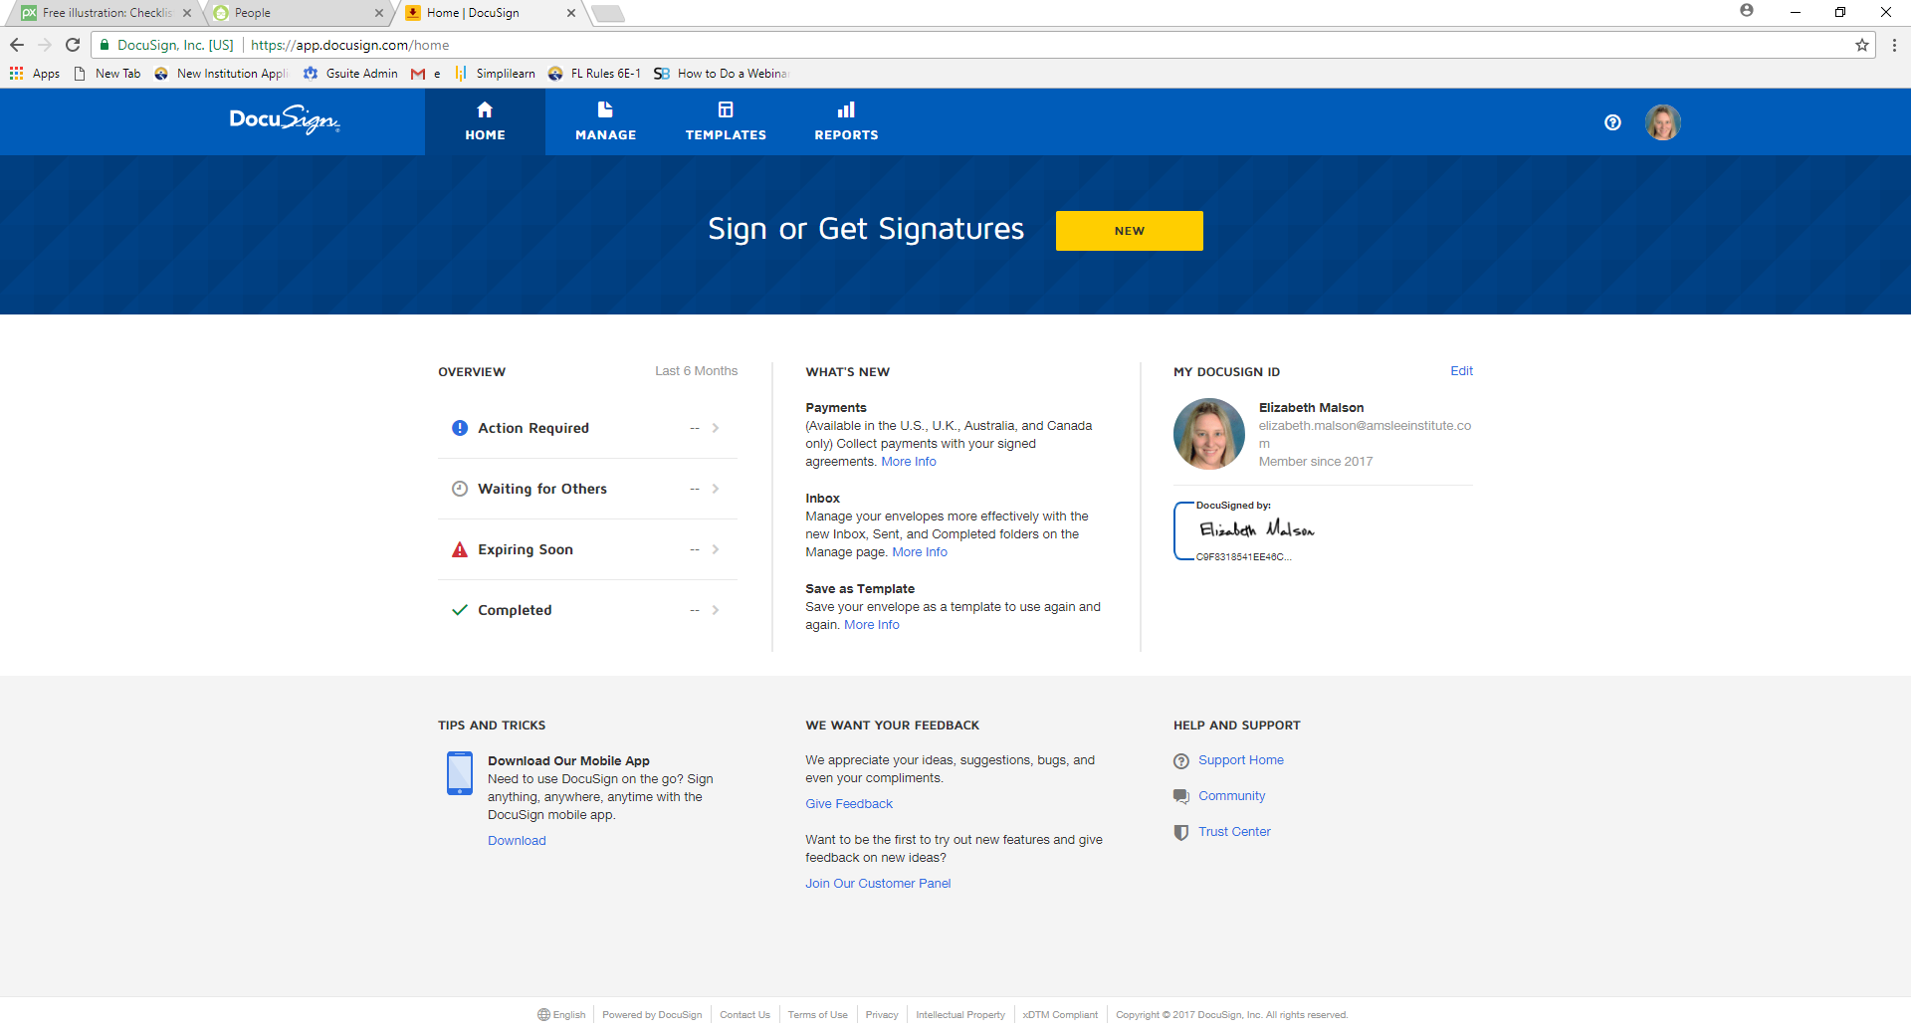 03/25/2025

US Nanny Association Signature (First and Last Name) (mm/dd/yyyy)  
  
Elizabeth Malson, Executive Director

Printed (First and Last Name) and Title